**Activity 8**

**Exercise 9.6(Activity 8)**

**9.6.1 Defining Terms**

**In your own words, define the following terms:**

**1. Class- is like an object constructor or a blueprint.**

**2. Object- is a member of a class**

**3. Instantiate- a constructor of a class and instantiate allocates the initial memory for the object and returns a reference.**

**4. Instance Variable- it is a variable that is declared in class but outside of constructors, methods or blocks.**

**5. Instance Method- is basically a method of the class or a non-static method which is declared inside a class.**

**6. Class Variables or static member variables- class variables also known as static variables are declared with the static keyword in a class.**

**7. Constructor- a special method that is used to initialize objects.**

**9.6.2 Java Scavenger Hunt**

**1. Look for a method that checks if a certain String ends with a certain suffix. For**

**example, if the given string is "Hello", the method should return true the suffix given**

**is "lo", and false if the given suffix is "alp".**

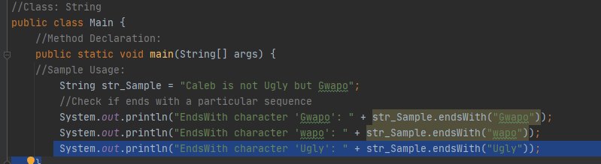

**Method Declaration:**

**public boolean endsWith(String suffix)**

**Output:**

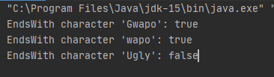

**2. Look for the method that determines the character representation for a specific digit**

**in the specified radix. For example, if the input digit is 15, and the radix is 16, the**

**method would return the character F, since F is the hexadecimal representation for**

**the number 15 (base 10).**

**Class: Character  
Method Declaration:**

**public static char forDigitRad(int digit, int radix)**

**Sample Usage:**

**char charValue = Character.forDigit(15, 16);**

**System.out.println(charValue);**

**Output: F**

**3. Look for the method that terminates the currently running Java Virtual Machine**

**Class:** **System**  
**Method Declaration:**

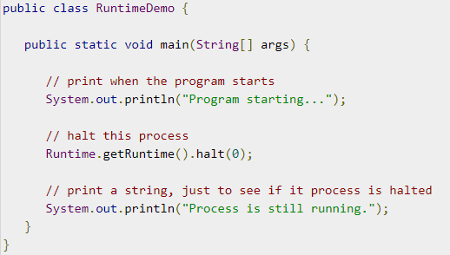

**Sample Usage:**

**Runtime.getRuntime().halt(0)**

**Output:**



**4. Look for the method that gets the floor of a double value. For example, if I input a**

**3.13, the method should return the value 3.**

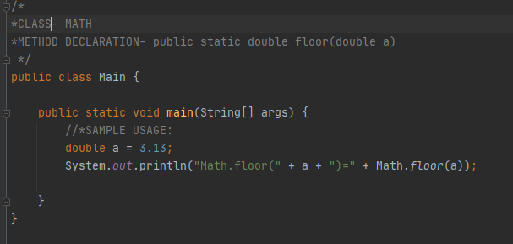

**Output:**



**5. Look for the method that determines if a certain character is a digit. For example, if I**

**input '3', it returns the value true.**

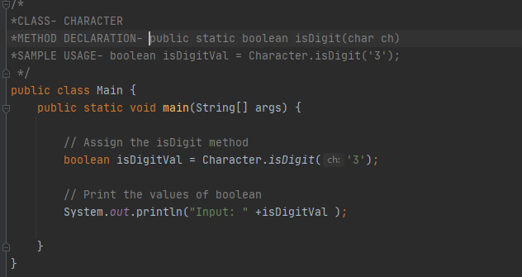

**Output:**

